LAB TEST:02
AI ASSISTED CODING
Hall ticket no:2402A53056
H.1:
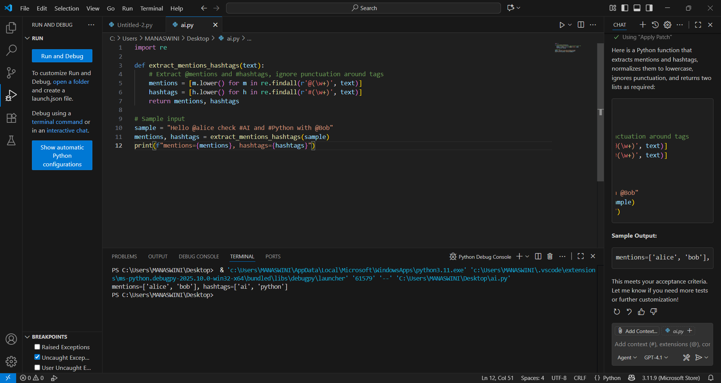
H.2:
